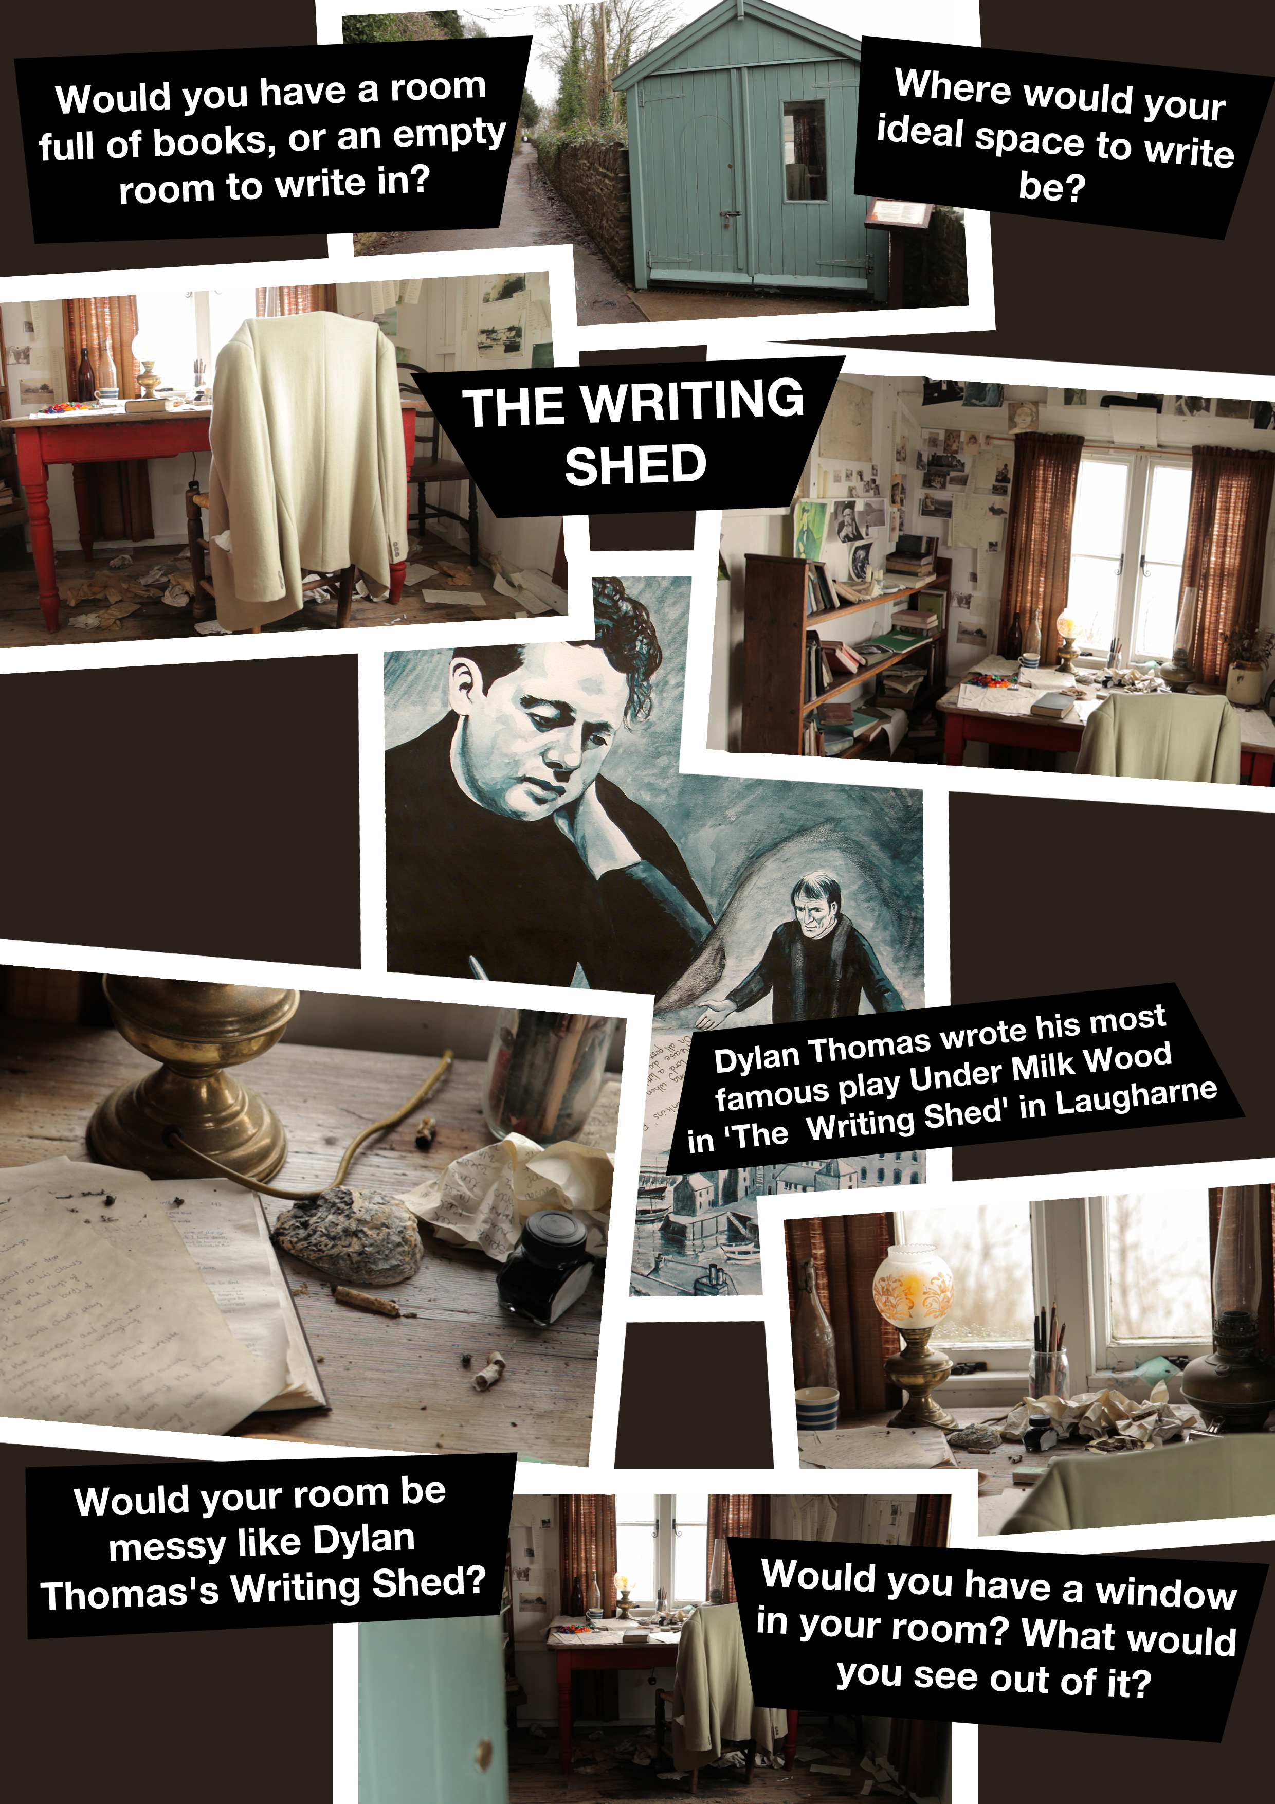

Teaching ideas
- Get learners to research which other famous writers had special writing areas http://www.pinterest.com/kevbo703/desks-and-offices-of-famous-people/

- Learners to write a description of what their ideal space would be
- Discuss:
‘Does a room have to be tidy to be able to write well in it?'
'A writing room should be windowless so that you are not distracted by the world outside.'
'It's easier to write if you have music on to drown out the sounds outside.'
- Learners to draw a map of their ideal writing room (top down) labelled with furniture and special features.

